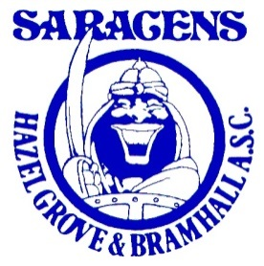
Hazel Grove & Bramhall ASC
Saracens Swim Shop
Order Form
Name:- Swimming Session Attended:- Mon/ Weds/ Thurs
Telephone:- (please circle) 6.15pm/6.45pm/7.30pm/8.30pm
Email:-

Item | Size | Price  £ | Quantity | Amount  £
Swim bag (personalised) | one | £22
Polo shirt (personalised) | Age 5-6, 7-8, 9-10, 11-12, 13 S/M/L/XL | £17
Hoodie (personalised) | Age 5-6, 7-8, 9-11, 12-13 S/M/L/XL | £22
Jammers | 24”, 26”, 28”,  30”, 32”, 34”, 36”, 38” | £17  £20
Swimsuit/  costume | 24”, 26”, 28”, 30”, 32”  Size:- 10,12,14,16,18 | £17  £20
Shorts (seniors only) | S/M/L/XL | £22
Aluminium Drinks Bottle  (personalised) | one | £11  £14
Towel (Bath Sheet)  100% cotton (Bath Towel) | 100cm x 150cm (personalised)  70cm x 130cm (personalised) | £25.50  £21
Bobble (Tassel) Hat | one | £9.50
Beanie Hat | one | £8
Swim hat | Available at training sessions | £7
TOTAL

Exact name to be personalised:

Please note orders will not be processed without payment.
Payment options:- cheque, cash or bank transfer; reference as: shop followed by your child’s name (please print screen transaction)
Ian & Jacqueline Harrison Email:- swimshop@saracens-asc.co.uk

For official use only:
Reference Number: Date:

